1. Change login screen to say “Pelco Breeze”.

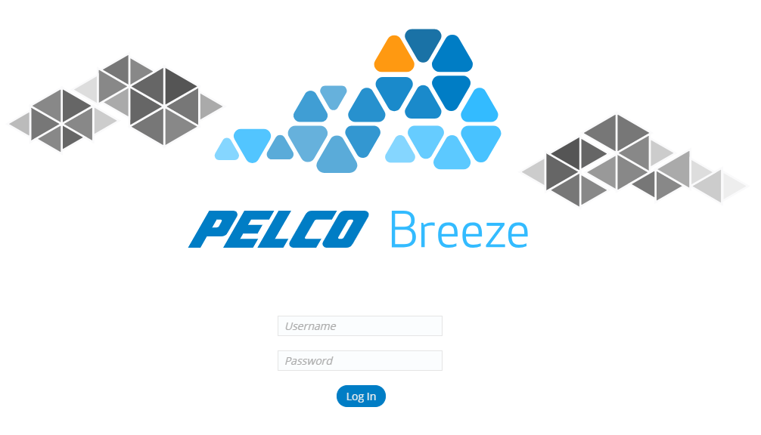

* Replace assets/images/branding/temp-pelco-cloud-wordmark.svg with

img/branding/temp-pelco-breeze-wordmark.svg (included in this zip).

1. Add graphics to page header.

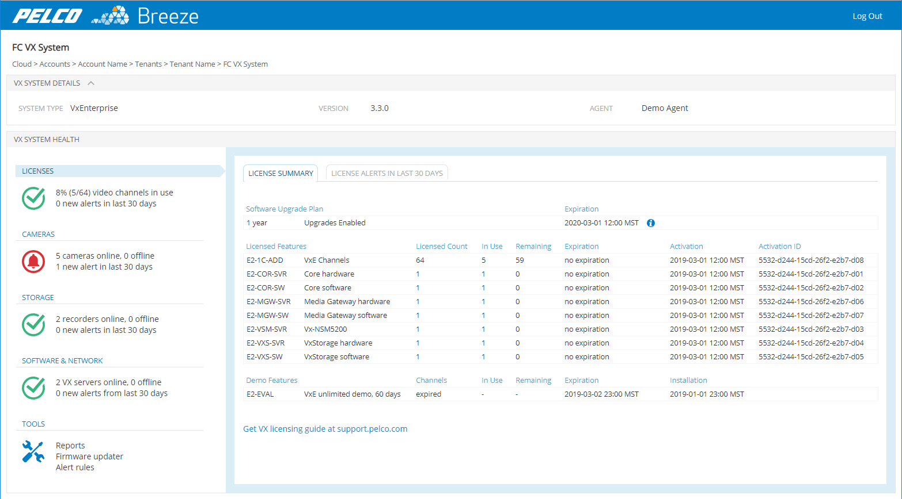

* My header looks like this:

<header>

<div class="branding">

<img class="pelco" src="../img/branding/temp-pelco-wordmark-white.svg">

<img class="logo" src="../img/branding/temp-cloud-logo-white.svg">

<img class="name" src="../img/branding/temp-breeze-wordmark-white.svg">

</div>

<div class="user"><a class="button" href="../login.html">Log Out</a></div>

</header>

* The first two images are already in the repo.
* img/branding/temp-breeze-wordmark-white.svg is included in this zip.
* Styles in base.less should already be correct.

1. Add max-height and auto overflow-y to table of logged alert events on alert workflow modal.

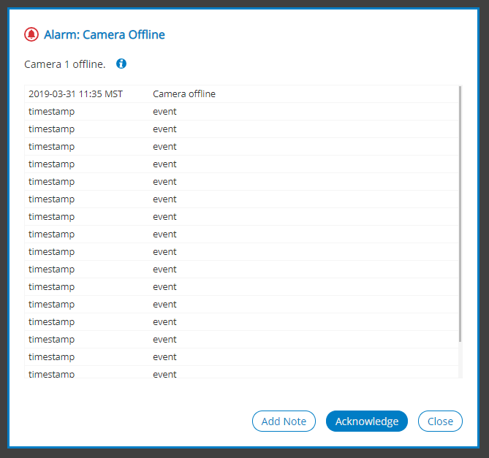

* In the modal HTML, wrap the table in a div and move class .alert-history to the wrapper div.

Like this:

<div class=“alert-history”>

<table class=“compact-list”>

<tbody>

(etc…)

</tbody>

</table>

</div>

* Replace alertWorkflow.less with the new alertWorkflow.less file in this zip.

1. Make notes and acknowledgements logged for an alert be by username “iscwest@pelco.com”.

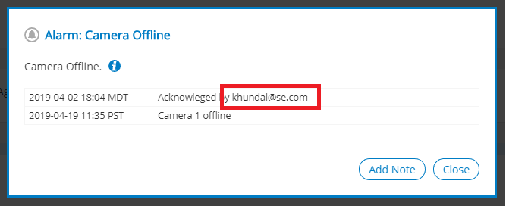

1. Make link in alert on Tenant Overview match first VX system in list. (Or just “Fort Collins VX”.)

Clicking on either link should navigate to the VX system health page.

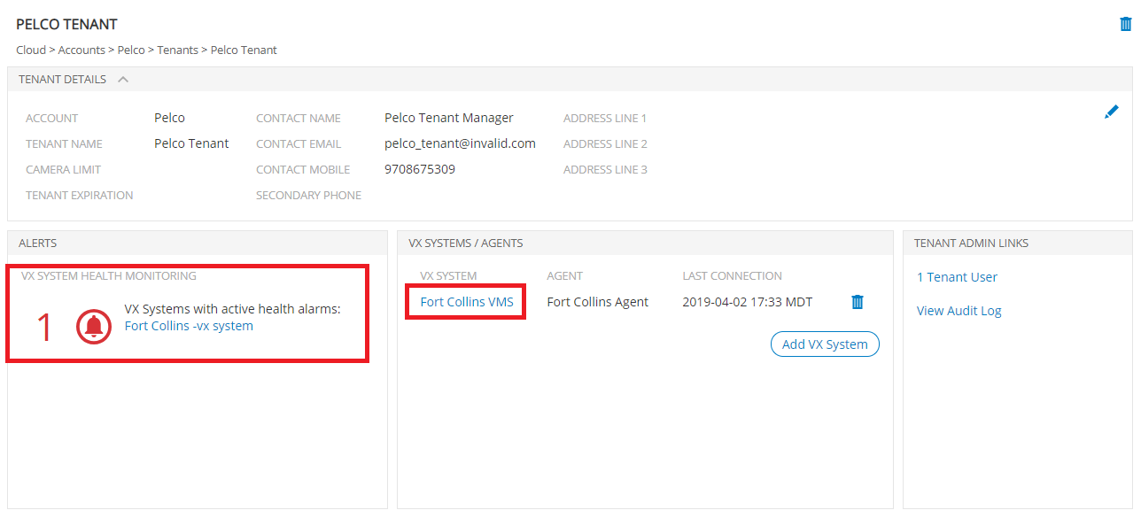

1. Make system type be “VxEnterprise”. The two possible values for system type are “VxProfessional” or “VxEnterprise”. We are trying to mockup an VxEnterprise system for the demo.

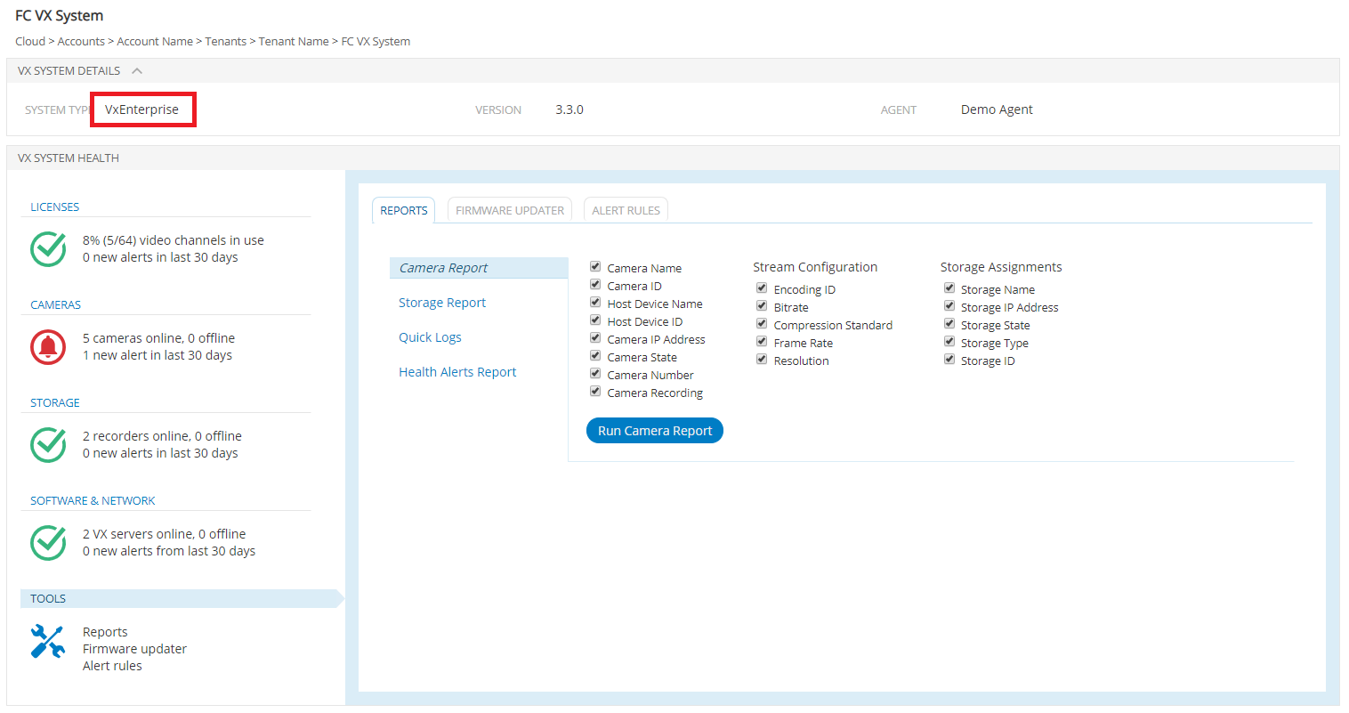

1. Make “Tools” icon be assets/images/icons/tools-pelcoBlue.svg (already in repo).

And make text say:

Reports

<br>

Firmware updater

<br>

Alert rules

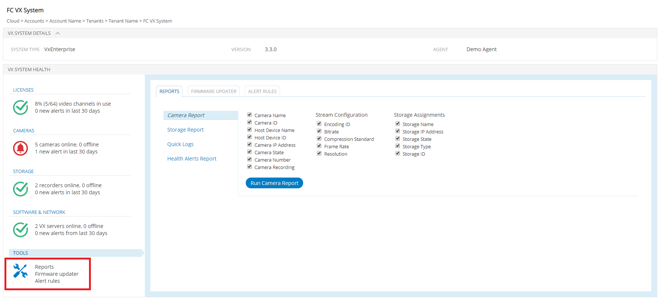

1. Not sure why the fake thumbnails aren’t displaying:

